Unit 3 – Lesson 6
Poetry: Forms of Poetry- Cinquain

There are many different types of poetry forms. In this lesson students will a cinquain poem. There are many other poetry forms of poetry and can be built upon for following up lessons, however this lesson will focus on cinquain poetry.

Topic: Poetry

Time Frame: 60 minutes

Driving question: What is a Cinquain poem?

Curriculum Outcomes –
7: Students will be expected to use writing and other forms of representation including digital to explore, clarify and reflect on their thoughts feelings and experiences and learnings.
Learning Target:
Grade 1 | Grade 2
Make decisions about word choice for specific reasons | Make decisions about word choice for specific reasons

Resources Needed:

- Collection of poetry books and poems
- Goal setting organizer
- Access to computers or iPads with familiar apps
- Writing Folder – to store writing at various stages
- Writer’s Notebook - to record ideas and goals for their writing

Lesson:

I Do:
Students should have an opportunity to interact with poetry. Texts and poems should be on display in the classroom and explored during shared or independent reading experiences. It is an important step for growing writers to read good mentor texts.
“We have studied and read many different types of poetry. We know that poets create many different poems for many different reasons. We know that there are free-verse poems, rhyming poems, and many others. Today we are going to focus on one type of poem called a cinquain poem. A cinquain poem follows a pattern and has 5 lines. There are actually three different types of patterns for cinquain, but we are just going to follow one.
Let’s look at some examples and see what we notice. Can you find the pattern?”
The pattern that we are going to follow is:
1 Words
2 Words
3 Words
4 Words
1 Words

We Do:
As a class, brainstorm a list of things that we know a lot about and feel strongly about. We are going to write this poem as a class and the topics should be about things we all know about. Choose a topic and complete the cinquain poem graphic organizer together.

You Do:
Students should spend time independently writing. Students should choose a topic that they feel strongly about and spend time drawing and writing about it. Encourage students to create a cinquain poem or the form of poetry that you are studying as a class. The organizer should be available for students who need or want the support.
As students are independently writing it will be important to conference with students one-on-one or in small groups.

We Share:
When students are finishing up we can gather together as a group. Students can have an opportunity to share their writing they completed independently. Remind students that poetry may be about many different things and usually have a strong feeling or emotion attached to them. Encourage students to give one another feedback about strong words in their poetry. Revisit the poetry rubric to see if we can identify areas of strength and areas of growth.

Differentiation/Adaptations:
This is embedded into the design of the lesson plan. Students who use an iPad for writing or as a documented adaptation will easily be able to complete this assignment on any app of their choice.

Assessments:
Record observations on students’ poetry skills in Evernote or however you choose to track your students.
Students can revisit the goal-setting sheet and evaluate if they have achieved their goal and to set another goal.

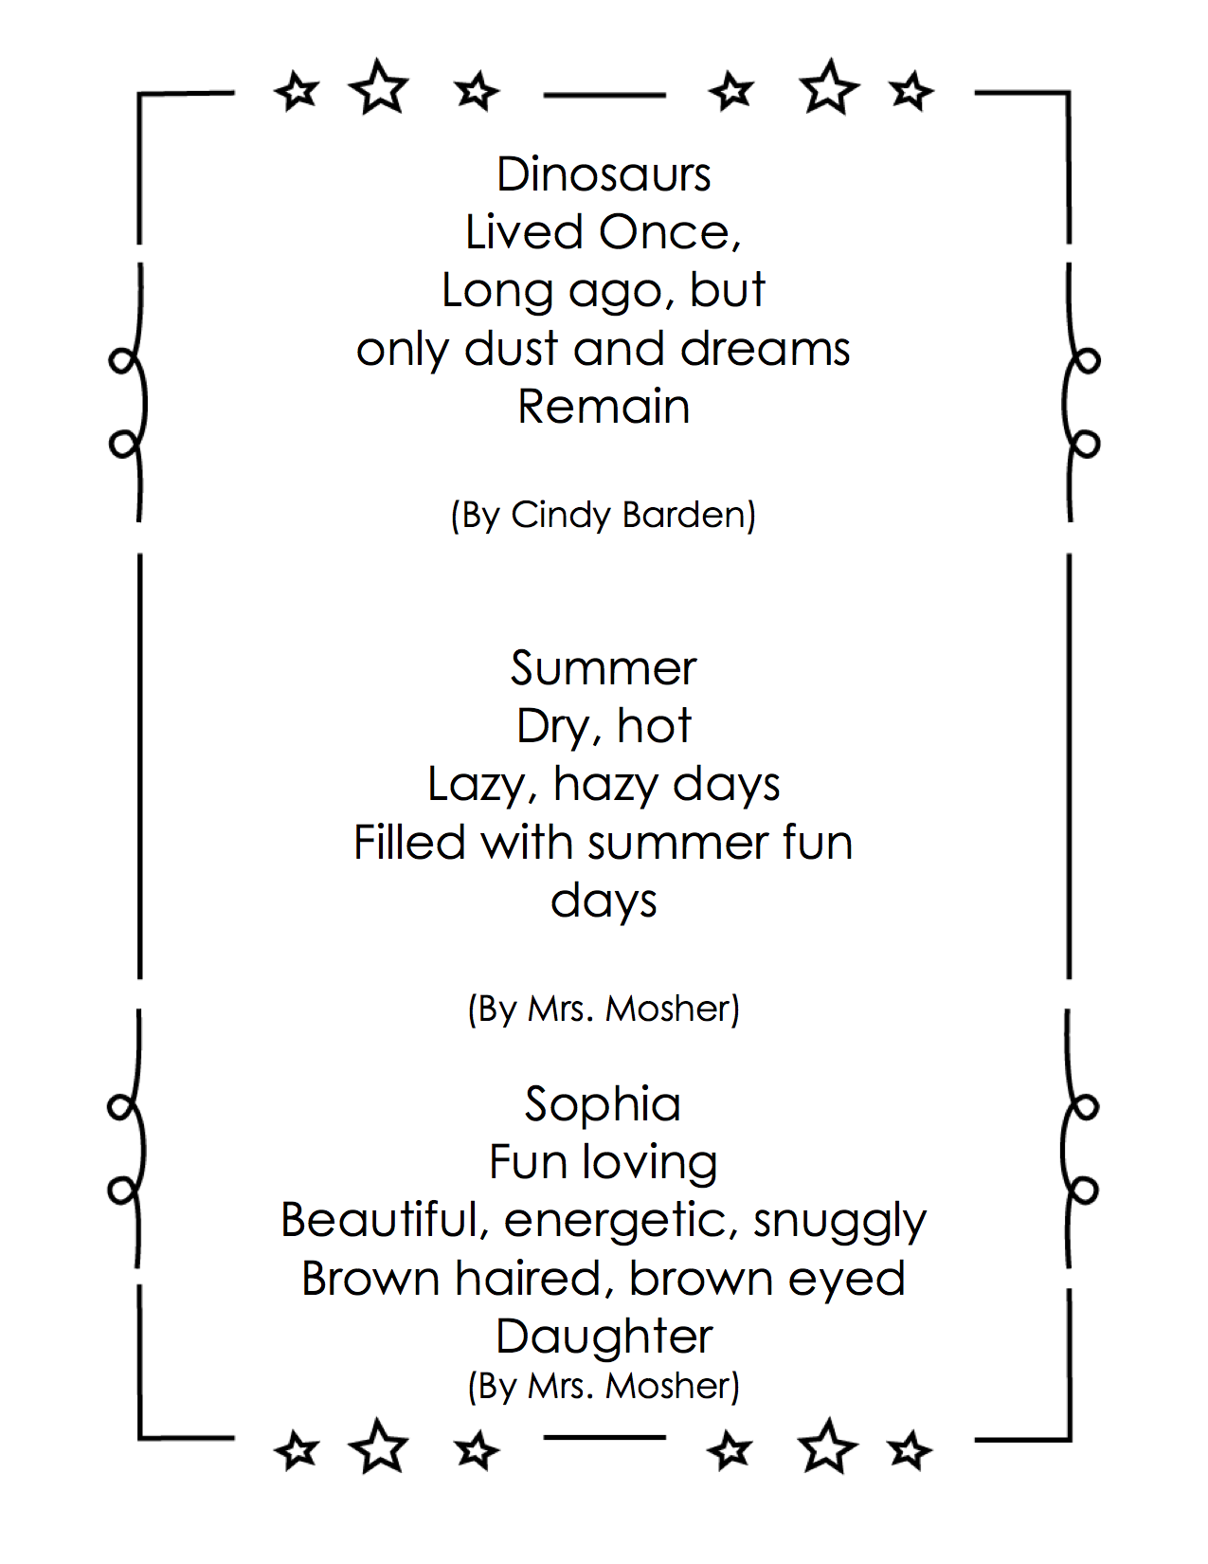
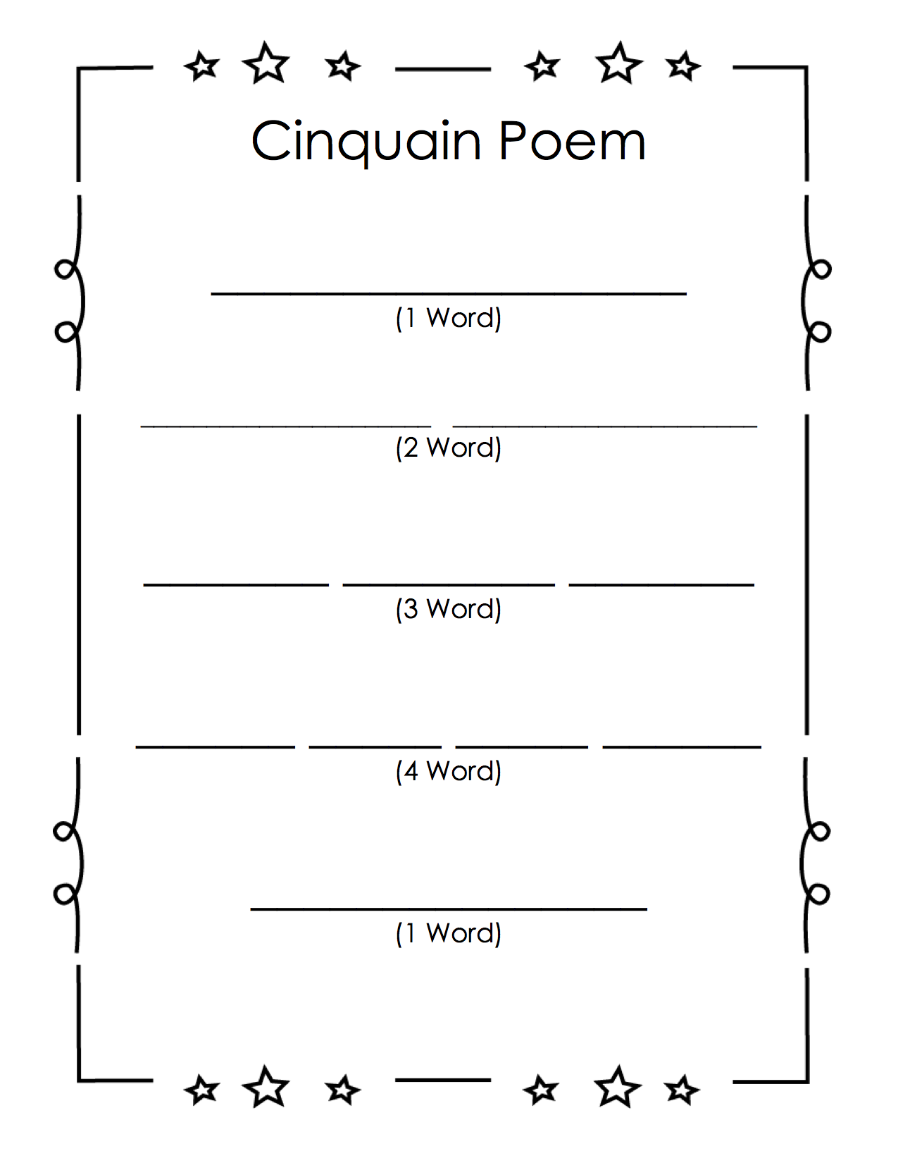
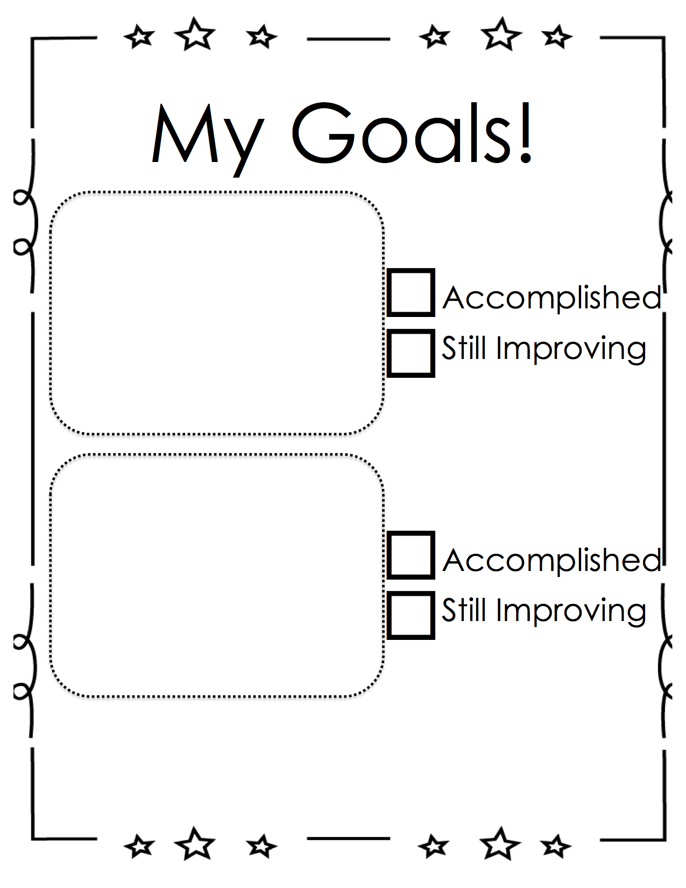

Categories | Level 1 | Level 1 | Level 3 | Level 4
Form | Does not use a poetic form | Somewhat uses a poetic form | Poem follows a poetic form | Poem clearly and effectively follows a poetic form
Word Choice | Uses basic words | Uses mostly basic and some interesting words | Attempts to use interesting words | Uses interesting words that paint a clear picture in the reader’s mind
Voice | There is no feeling in your writing | Little feeling about your topic is expressed | Feeling about your topic is expressed | Strong feelings and emotions about your topic is expressed
Sentences | No evidence of simple sentences | Few simple sentences, sometimes incomplete | Simple, complete sentences | Variety in simple and complete sentences
Spelling | Uses only random letters | Uses some spelling strategies | Uses strategies for spelling | Familiar words are spelled correctly
Capital Letters | No capital letters or in the wrong place | Some use of capital letters | Mostly uses capital letters properly | Uses all capital letters accurately
Periods | No periods are used | Some periods at the end of some sentences | Mostly uses periods properly | Uses periods properly
Visual Presentation | Visual presentation is unclear (spacing, placement, legibility | Visual presentation is basically clear | Clear visual presentation | Clear presentation that enhances the writing.
Poetry Rubric

