Unit 3 – Lesson 5
Poetry: Words, Words, Words

In this lesson students will explore an author’s choice of words in his or her poetry. Students will be encouraged to explore poems with strong word choice and examine word choice in their poetry.

Topic: Poetry

Time Frame: 60 minutes

Driving question: Why is word choice important?

Curriculum Outcomes –
7: Students will be expected to use writing and other forms of representation including digital to explore, clarify and reflect on their thoughts feelings and experiences and learnings.
Learning Target:
Grade 1 | Grade 2
Make decisions about word choice for specific reasons | Make decisions about word choice for specific reasons

Resources Needed:

- Collection of poetry books and poems
- Goal setting organizer
- Love and dislike word choice activity sheet
- Access to computers or iPads with familiar apps
- Writing Folder – to store writing at various stages
- Writer’s Notebook - to record ideas and goals for their writing

Lesson:

I Do:
Students should have an opportunity to interact with poetry. These should be on display in the classroom and explored during shared or independent reading experiences. It is an important step for growing writers to read good mentor texts.

Share poetry with strong word choices with the students. Talk about how words we choose influence our poetry.
“Poet’s make specific choices and think about the words that they are including in their poem. Let’s look at the poem “The Fog”. There are two versions. Which one do you find more interesting?
“Are there words that create strong images? What words help to paint a picture in your mind?”

We Do:
Have students fill in the blanks, “I love __________” and “I dislike _________”. Ask students, “Is there another way (another word choice) that you could use to paint a strong image in your reader’s mind?”
For instance: I love chocolate. I might say, “I crave chocolate” or “The smell of chocolate makes my mouth water.”
Or instead of, “I dislike snakes” I might say, “I despise snakes, they make me want to run away screaming.”
Have students complete the activity and share their word choices with their peers.

You Do:
Students should spend time independently writing. Students should choose a topic that they feel strongly about and spend time drawing and writing about it. Encourage students to think about their word choices. Have them choose a word or sentence that they think they could make stronger. Encourage students to revise their work so they paint a stronger image in their readers’ minds.
As students are independently writing it will be important to conference with students one-on-one or in small groups. Students can use the graphic organizer to help them brainstorm ideas during the writing process.

We Share:
When students are finishing up we can gather together as a group. Students can have an opportunity to share their writing they completed independently. Remind students that poetry may be about many different things and usually have a strong feeling or emotion attached to them. Encourage students to give one another feedback about strong words in their poetry. Revisit the poetry rubric to see if we can identify areas of strength and areas of growth.

Differentiation/Adaptations:
This is embedded into the design of the lesson plan. Students who use an iPad for writing or as a documented adaptation will easily be able to complete this assignment on any app of their choice.

Assessments:
Record observations on students’ poetry skills in Evernote or however you choose to track your students.
Students can revisit the goal-setting sheet and evaluate if they have achieved their goal and to set another goal.

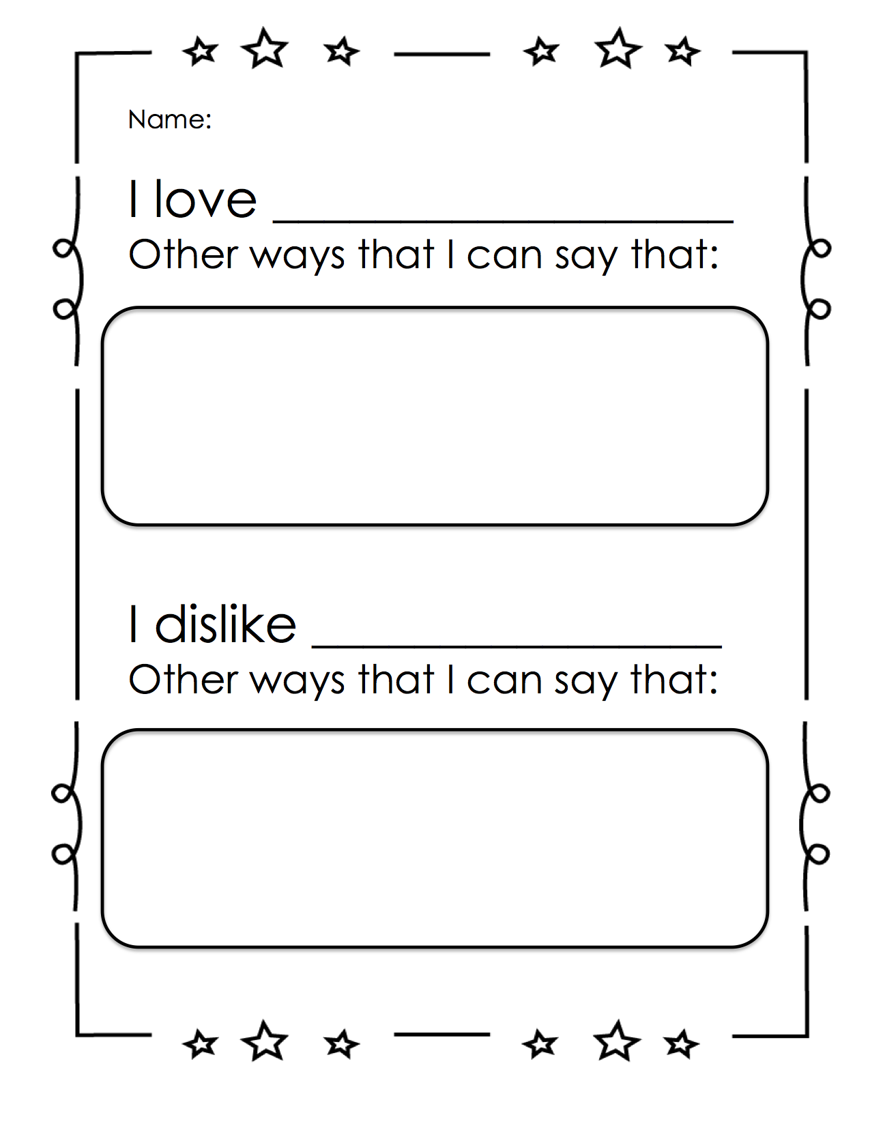
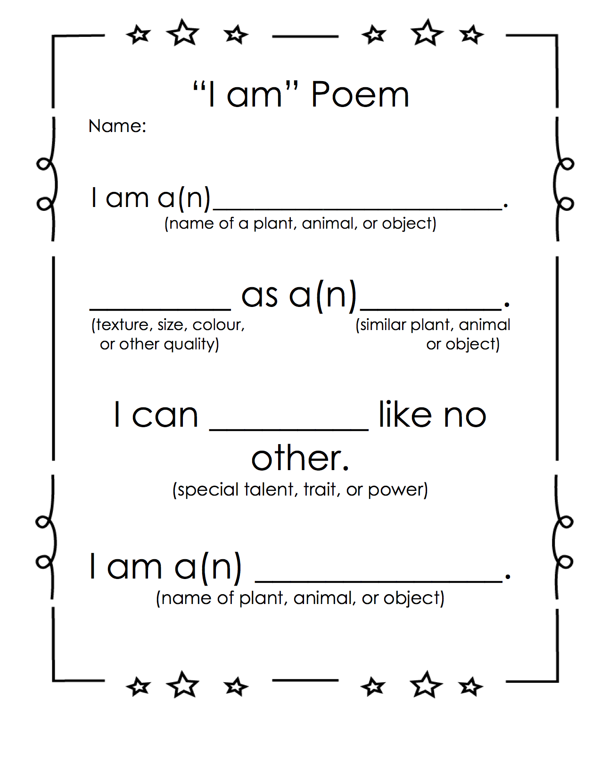
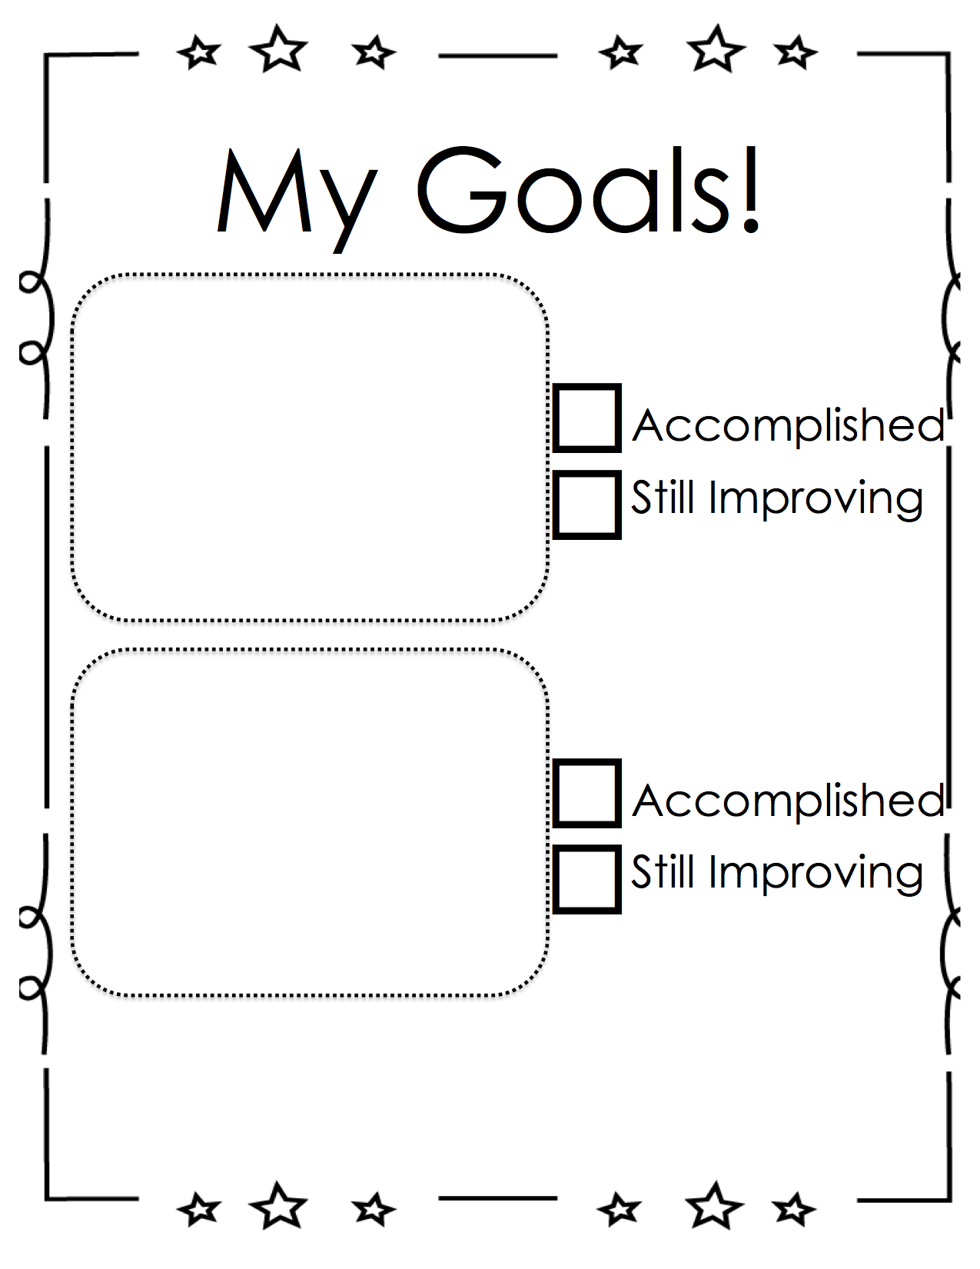

Categories | Level 1 | Level 1 | Level 3 | Level 4
Form | Does not use a poetic form | Somewhat uses a poetic form | Poem follows a poetic form | Poem clearly and effectively follows a poetic form
Word Choice | Uses basic words | Uses mostly basic and some interesting words | Attempts to use interesting words | Uses interesting words that paint a clear picture in the reader’s mind
Voice | There is no feeling in your writing | Little feeling about your topic is expressed | Feeling about your topic is expressed | Strong feelings and emotions about your topic is expressed
Sentences | No evidence of simple sentences | Few simple sentences, sometimes incomplete | Simple, complete sentences | Variety in simple and complete sentences
Spelling | Uses only random letters | Uses some spelling strategies | Uses strategies for spelling | Familiar words are spelled correctly
Capital Letters | No capital letters or in the wrong place | Some use of capital letters | Mostly uses capital letters properly | Uses all capital letters accurately
Periods | No periods are used | Some periods at the end of some sentences | Mostly uses periods properly | Uses periods properly
Visual Presentation | Visual presentation is unclear (spacing, placement, legibility | Visual presentation is basically clear | Clear visual presentation | Clear presentation that enhances the writing.
Poetry Rubric

