Unit 3 – Lesson 3
Poetry: What is a Rhyme?

In this lesson students will explore rhymes and rhyming poems. Students will be encouraged to explore poems with a rhyme scheme and see if they can identify a pattern.

Topic: Poetry

Time Frame: 60 minutes

Driving question: What is a rhyme?

Curriculum Outcomes –
9: Students will use a range of strategies to develop effective writing and media products to enhance their clarity, precisions, and effectiveness.
Learning Target:
Grade 1 | Grade 2
Recognize and generate spoken words that rhyme  Write a variety of poems | Demonstrate an increasing knowledge of spelling patterns  Write a variety of poetry

Resources Needed:

- Collection of poetry books and poems
- Poems that rhyme for students to study (2 examples below)
- Goal setting set
- Brainstorming graphic organizer
- Access to computers or iPads with familiar apps
- Writing Folder – to store writing at various stages
- Writer’s Notebook - to record ideas and goals for their writing

Lesson:

I Do:
Students should have an opportunity to interact with poetry. These should be on display in the classroom and explored during shared or independent reading experiences. It is an important step for growing writers to read good mentor texts.

Ask students if they know what the word “rhyme” means. Allow for student response and discussion. Share two rhyming poems with the students. Have copies of the poems available for the students or have them projected on the white board. See if students can find words that rhyme and highlight these words. Talk about rhyming words in poetry.

We Do:
Rhyming Word Activity
Provide students with brainstorming flower graphic organizer. Have a word written in the center of the flower. Practicing word families would work for this activity as well. In groups of 3-4 students can fill in the petals of the flower with rhyming words. The rhyming word flowers can be on display for students to use during their independent writing time.
Model how the graphic organizer can be used to brainstorm about a topic of a poem as well. See example below.

You Do:
Students should spend time independently writing. Students should choose a topic that they feel strongly about and spend time drawing and writing about it. Encourage students to think about rhyming words and see if they can add rhyming words in their poetry. As students are independently writing it will be important to conference with students one-on-one or in small groups. Students can use the graphic organizer to help them brainstorm ideas during the writing process.

We Share:
When students are finishing up we can gather together as a group. Students can have an opportunity to share their writing they completed independently. Remind students that poetry may be about many different things and usually have a strong feeling or emotion attached to them. Encourage students to give one another feedback about the use of rhyme in their poetry. Revisit the poetry rubric to see if we can identify areas of strength and areas of growth.

Differentiation/Adaptations:
This is embedded into the design of the lesson plan. Students who use an iPad for writing or as a documented adaptation will easily be able to complete this assignment on any app of their choice.

Assessments:
Record observations on students’ poetry skills in Evernote or however you choose to track your students.
Students can revisit the goal-setting sheet and evaluate if they have achieved their goal and to set another goal.

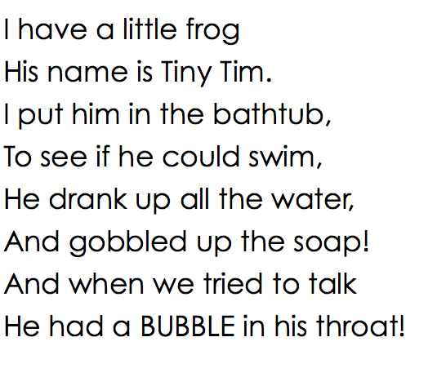
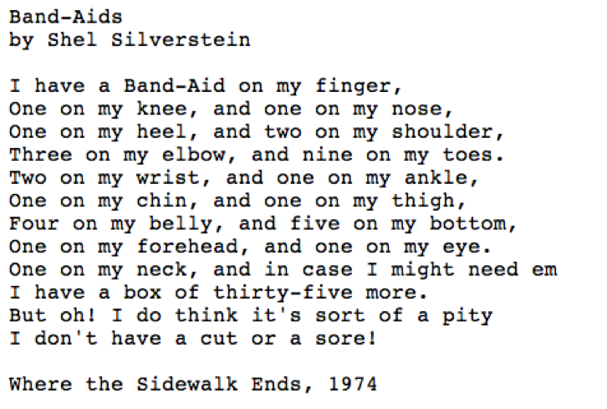
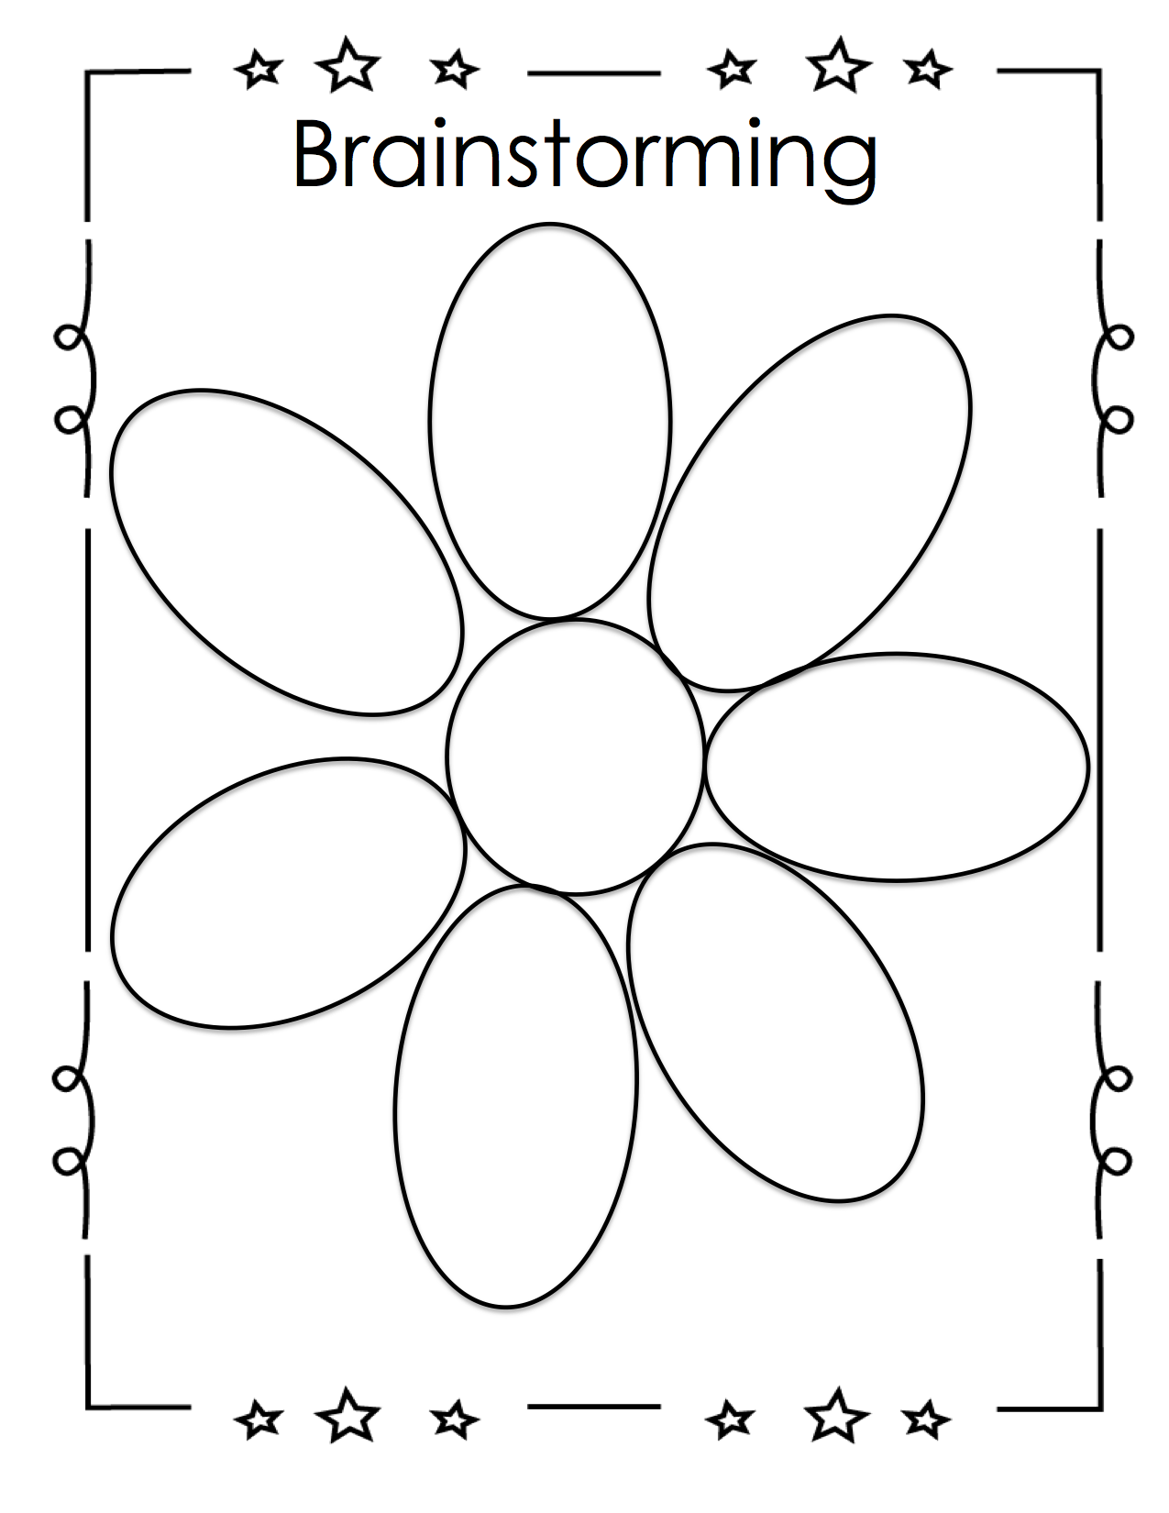

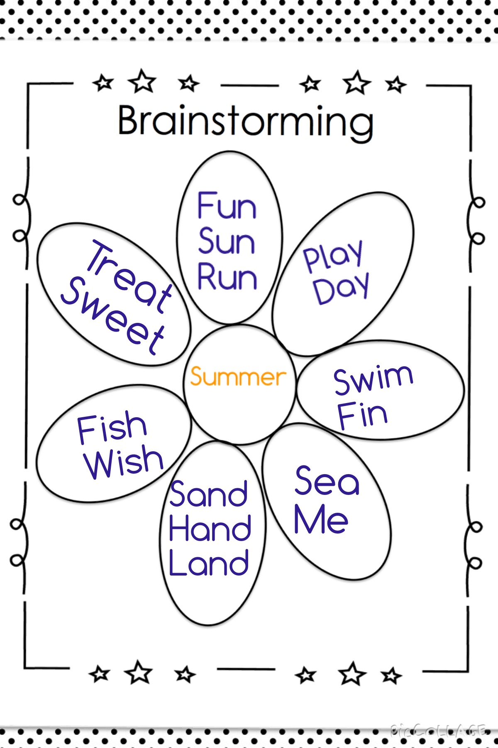

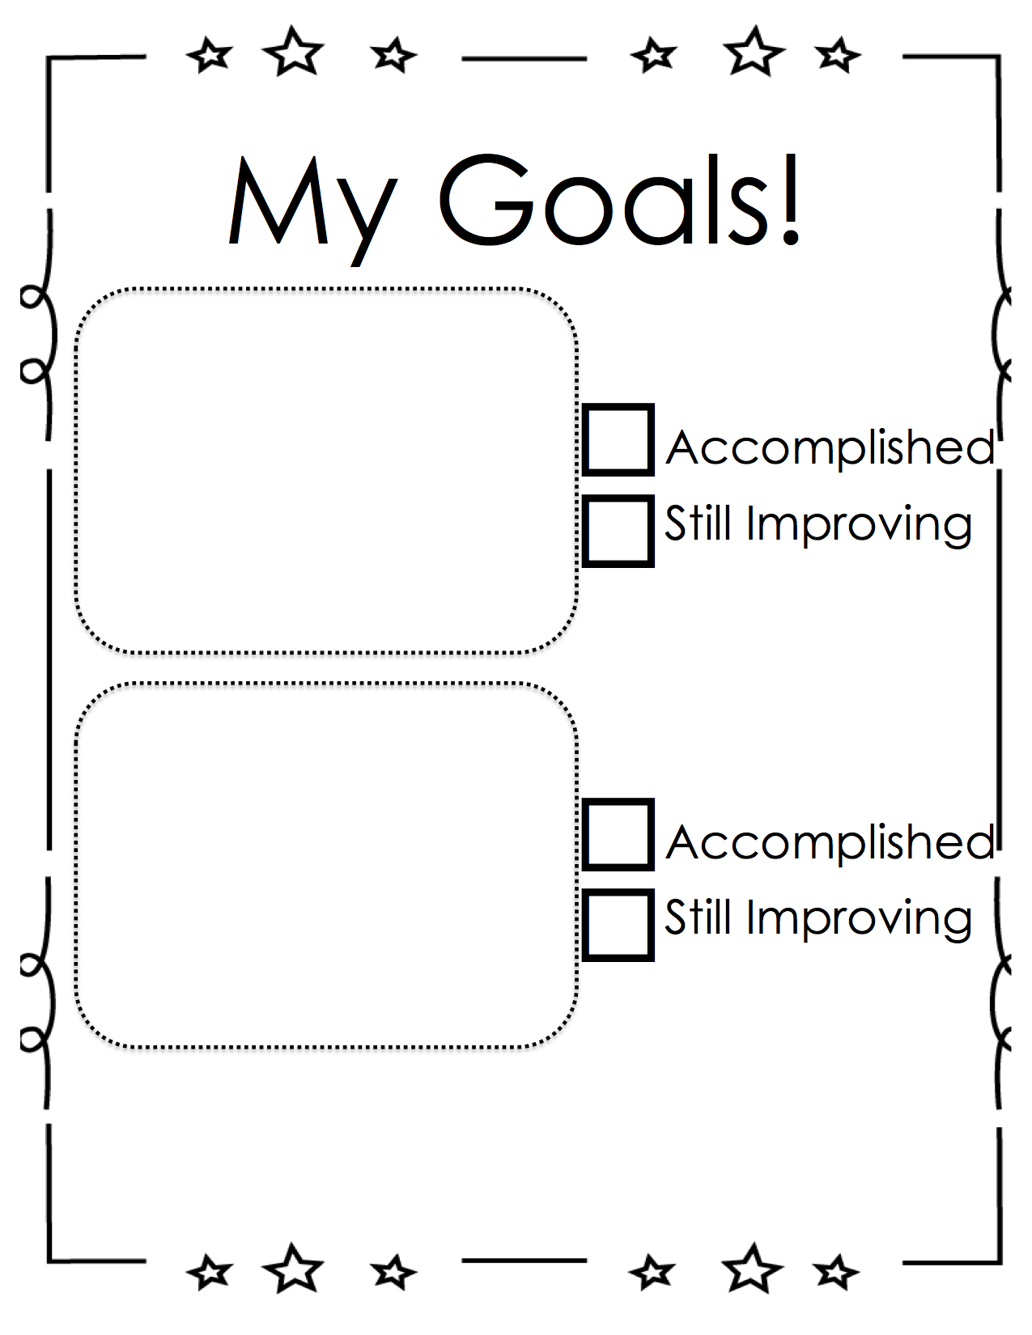

Categories | Level 1 | Level 1 | Level 3 | Level 4
Form | Does not use a poetic form | Somewhat uses a poetic form | Poem follows a poetic form | Poem clearly and effectively follows a poetic form
Word Choice | Uses basic words | Uses mostly basic and some interesting words | Attempts to use interesting words | Uses interesting words that paint a clear picture in the reader’s mind
Voice | There is no feeling in your writing | Little feeling about your topic is expressed | Feeling about your topic is expressed | Strong feelings and emotions about your topic is expressed
Sentences | No evidence of simple sentences | Few simple sentences, sometimes incomplete | Simple, complete sentences | Variety in simple and complete sentences
Spelling | Uses only random letters | Uses some spelling strategies | Uses strategies for spelling | Familiar words are spelled correctly
Capital Letters | No capital letters or in the wrong place | Some use of capital letters | Mostly uses capital letters properly | Uses all capital letters accurately
Periods | No periods are used | Some periods at the end of some sentences | Mostly uses periods properly | Uses periods properly
Visual Presentation | Visual presentation is unclear (spacing, placement, legibility | Visual presentation is basically clear | Clear visual presentation | Clear presentation that enhances the writing.
Poetry Rubric

