Unit 3 – Lesson 2
Poetry: How do readers read poems?

In this lesson students will explore how to read a poem. This lesson will provide students with continued practice in reading with a focus on fluency and punctuation.

Topic: Poetry

Time Frame: 60-90minutes

Driving question: How do readers read poems?

Curriculum Outcomes –
3: Students will demonstrate a variety of ways to comprehend and select from a range of culturally diverse texts.
7: Students will be expected to use writing and other forms of representation including digital to explore, clarify and reflect on their thoughts, feeling and experiences, and learnings.
Learning Target:
Grade 1 | Grade 2
Begin to use punctuation to guide intonation and expression, change the tone and emphasis for bold print.  Write a variety of poems | Use punctuation marks to guide intonation and expression. Begin to change the rate of reading depending on the mood of the text.  Write a variety of poetry

Resources Needed:

- Collection of poetry books and poems
- Two poems that read differently to share with the class
- Access to computers or iPads with familiar apps
- Writing Folder – to store writing at various stages
- Writer’s Notebook - to record ideas and goals for their writing

Lesson:

I Do:
Students should have an opportunity to interact with poetry. These should be on display in the classroom and explored during shared or independent reading experiences. It is an important step for growing writers to read good mentor texts.

Share two poems with the students that are read in very different ways (at the bottom of this lesson). Have copies of the poems available for the students or have them projected on the white board.
Highlight the punctuation that makes us read poems in a certain way. Have students look for and highlight periods. Periods tell us to stop at the end of the sentence. Ask students what exclamation points mean. When we come to the end of the line if there is no punctuation that means that we do not always have to stop.
Model this for students.

We Do:
Provide students with copies of the simple poems that you shared with the class. Have students work with a partner to read the poem out loud. The repeated practice is helpful for students who are just starting to read. Repeated practice also helps with fluency.
Students can also use the iPads to voice record their read aloud. Using book creator, the students can illustrate their poem. This can also be easily done in iMovie or Explain Everything. It is personal preference for the student and the teacher.
Students, if they would like, may share their poetry readings with the class.

You Do:
Students should spend time independently writing. Students should choose a topic that they feel strongly about and spend time drawing and writing about it. Remind students that they are to use the steps in the writing process and to think about the traits of writing. As students are independently writing it will be important to conference with students one-on-one or in small groups. As we get further into the poetry unit students will be exploring different poetry forms with graphic organizers. They will be encouraged to write using one of these forms. The continued practice of free writing about feelings, emotions, or experiences is an important step to poetry writing.

We Share:
When students are finishing up we can gather together as a group. Students can have an opportunity to share their writing they completed independently. Remind students that poetry may be about many different things and usually have a strong feeling or emotion attached to them. Encourage students to give one another feedback about the feeling or emotions in their writing. Revisit the poetry rubric to see if we can identify areas of strength and areas of growth.

Differentiation/Adaptations:
This is embedded into the design of the lesson plan. Students who use an iPad for writing or as a documented adaptation will easily be able to complete this assignment on any app of their choice.

Assessments:
Record observations on students’ poetry skills in Evernote or however you choose to track your students.
Have students set a goal for their poetry writing.
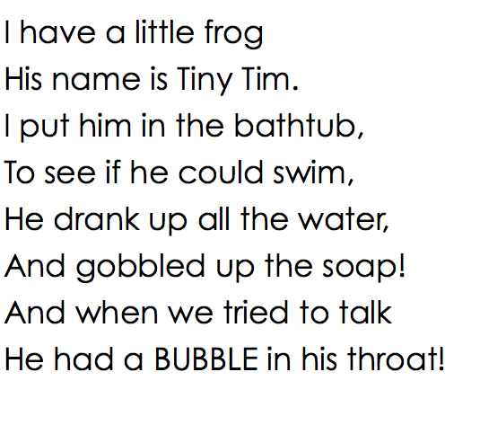

Fog
By Carl Sandburg

The fog comes
on little cat feet.

It sits looking
over harbor and city
on silent haunches
and then moves on.

My Goals!
Accomplished

Still Improving

Still Improving
Accomplished

Categories | Level 1 | Level 1 | Level 3 | Level 4
Form | Does not use a poetic form | Somewhat uses a poetic form | Poem follows a poetic form | Poem clearly and effectively follows a poetic form
Word Choice | Uses basic words | Uses mostly basic and some interesting words | Attempts to use interesting words | Uses interesting words that paint a clear picture in the reader’s mind
Voice | There is no feeling in your writing | Little feeling about your topic is expressed | Feeling about your topic is expressed | Strong feelings and emotions about your topic is expressed
Sentences | No evidence of simple sentences | Few simple sentences, sometimes incomplete | Simple, complete sentences | Variety in simple and complete sentences
Spelling | Uses only random letters | Uses some spelling strategies | Uses strategies for spelling | Familiar words are spelled correctly
Capital Letters | No capital letters or in the wrong place | Some use of capital letters | Mostly uses capital letters properly | Uses all capital letters accurately
Periods | No periods are used | Some periods at the end of some sentences | Mostly uses periods properly | Uses periods properly
Visual Presentation | Visual presentation is unclear (spacing, placement, legibility | Visual presentation is basically clear | Clear visual presentation | Clear presentation that enhances the writing.
Poetry Rubric

