Unit 2 – Lesson: 4
Fiction- Character

In this lesson students will begin to explore the elements of a story. This lesson will focus on the characters in a story.

Topic: Writing Process-Fiction Elements

Time Frame: 60 minutes

Driving question: Who are the characters in your story? Why are characters important to your story?

Curriculum Outcomes –
6: Students will convey meaning by creating print and digital texts collaboratively and independently using imagination, personal experiences, and feelings.

Learning Target:
Grade 1 | Grade 2
Express my ideas in complete thoughts | Express my ideas in complete thoughts using simple and compound sentences

Resources Needed:
- Graphic organizers for teaching about character (see link below in lesson)
- Screencast: https://www.youtube.com/watch?v=Fe-2rjqfUNA
- Access to computers or iPads with familiar apps
- Writing Folder – to store writing at various stages
- Writer’s Notebook - to record ideas and goals for their writing

Lesson:

I Do:
Students should have an opportunity to interact with mentor texts for fiction stories. These should be on display in the classroom and explored during shared or independent reading experiences. This is an important step for growing writers.
Here is a link to a page with suggestions for picture books with strong characters:
http://www.readwritethink.org/files/resources/lesson_images/lesson101/101BookList.pdf
Choose a book to share with students. Talk about the outside and inside of a character. The outside tells us what a character looks like; it’s what we would see. The inside of a character is the character’s traits (the way a character acts, thinks, or feels). One of my favorite books to talk about is “Chrysanthemum” by Kevin Henkes.

We Do:

Show the screencast: https://www.youtube.com/watch?v=Fe-2rjqfUNA
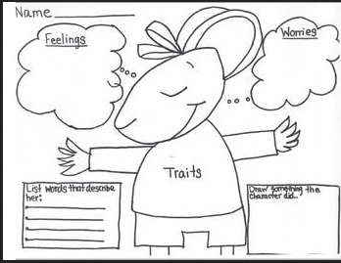
After reading the story “Chrysanthemum” and talking about the outside and inside of a character. Complete the graphic organizer with students about Chrysanthemum.

https://www.teacherspayteachers.com/Product/Chrysanthemum-Activities-450308

Ask students, “Why is it important for us to think about our characters in our story?”
Allow for discussion.

You Do:
Remind students that the previous day they were drafting and getting their ideas down on paper and were thinking about the setting of their story.
“Today we are going to revisit our drafts to see if we have developed the characters in our stories? Have we described them?
Encourage students to draw a picture of their main character. Have the students describe what they look like on the outside and also describe what they may be thinking or feeling.
Students can use their iPads, the computer, or the worksheet below to complete this activity.

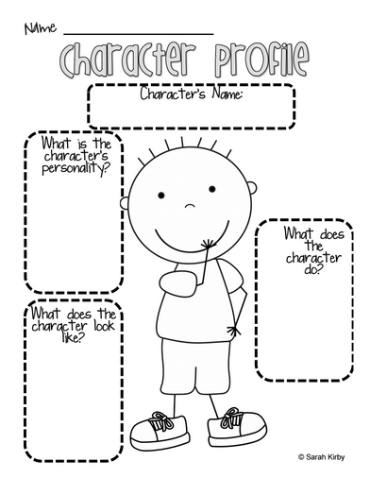
http://permanentlyprimary.blogspot.ca/2012/09/focus-wall-and-freebie.html

After students complete their character profile, encourage
the students to return to the writing that they started on the previous day. They should examine their writing to see if they have described their characters.
As students are independently writing, the teacher can conference with students one-on-one or in small groups.

We Share:

When students are finishing up we can gather together as a group. Students can have an opportunity to share their writing. Celebrate all levels of writing and point out in the strengths and provide on the spot feedback specifically about the characters in their story.

Differentiation/Adaptations:

This is embedded into the design of the lesson plan. Students who use an iPad for writing or as a documented adaptation will easily be able to complete this assignment on any app of their choice.

Assessments:

Record observations on students’ prewriting skills in Evernote or however you choose to track your students.

Fiction Writing Rubric
Categories | Level 1 | Level 1 | Level 3 | Level 4
Ideas | Uses 1 simple idea not connected to your topic | Uses 2-3 ideas that are connected to your topic | Uses 4 ideas connected to your topic | Uses 4 or more ideas connected to your topic
Details | Uses 1 supporting detail | Few supporting details but not enough to make the reader see, feel, hear your description | Uses an increasing number of details. | Uses a variety of details to help the reader see, feel, or hear the description
Voice | There is no feeling in your writing | Little feeling about your topic is expressed | Feeling about your topic is expressed | Strong feelings and emotions about your topic is expressed
Sentences | No evidence of simple sentences | Few simple sentences, sometimes incomplete | Simple, complete sentences | Variety in simple and complete sentences
Spelling | Uses only random letters | Uses some spelling strategies | Uses strategies for spelling | Familiar words are spelled correctly
Capital Letters | No capital letters or in the wrong place | Some use of capital letters | Mostly uses capital letters properly | Uses all capital letters accurately
Periods | No periods are used | Some periods at the end of some sentences | Mostly uses periods properly | Uses periods properly
Visual Presentation | Visual presentation is unclear (spacing, placement, legibility | Visual presentation is basically clear | Clear visual presentation | Clear presentation that enhances the writing.

