Unit 2 – Lesson: 1
Fiction- Brainstorming

In this lesson students will explore how to use brainstorming to get started on a piece of writing. We will specifically looking at fiction writing. Students will demonstrate an understanding that fiction is made up stories. They will explore the different elements of fiction.

Topic: Writing Process-Fiction Elements

Time Frame: 60 minutes

Driving question: How do growing writers get started on a piece of writing?

Curriculum Outcomes –
9: Students will use a range of strategies to develop effective writing and media products to enhance their clarity, precision and effectiveness.

Learning Target:
Grade 1 | Grade 2
Talk about the ideas they plan to write about, draw pictures to help develop ideas for writing, begin to use simple graphic organizer | Talk about the ideas they plan to write about, draw pictures to develop ideas for writing, choose and use simple graphic organizers

Resources Needed:

- Access to computers or iPads with familiar apps
- Copies of the graphic organizers listed below
- Writing Folder – to store writing at various stages
- Writer’s Notebook-­‐ to record ideas and goals for their writing

Lesson:

I Do:
Students should have an opportunity to interact with good mentor texts for fiction stories. These should be on display in the classroom and explored during shared or independent reading experiences. This is an important step for growing writers.
Choose your favorite picture book and read aloud with students. Talk about the parts of the book that you really like (maybe it’s the character’s, setting, or how the book ends).
You can also invite students to bring in their favorite picture book (fiction) to use for the shared portion of this lesson.

We Do:
Invite students to think about their favorite picture book. Have them turn and talk to a partner about why their book is their favorite. What makes the book special?
“We will not have enough time to read everyone’s book, but we can share why we like the book, an exciting part, or what makes the book special.”
Point out that each of the books has a different author and illustrator. Ask students if they know each of those roles are.
Ask students, “How do you think the author’s know what to write? How you do you think they get started? How do you get started? What helps you to write?
Introduce brainstorming graphic organizers. There is a smartboard file with the graphic organizers to review and complete as a whole class.
https://drive.google.com/open?id=0B_c7VW5IHTVSfmxtOTZVNlFyTFExckE3WEZ0M25UVjduYmxJQXEwclZFUS1jS1U1V3dWYkE

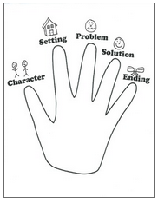
https://www.teacherspayteachers.com/Product/Five-Finger-Story-Structure-1301655

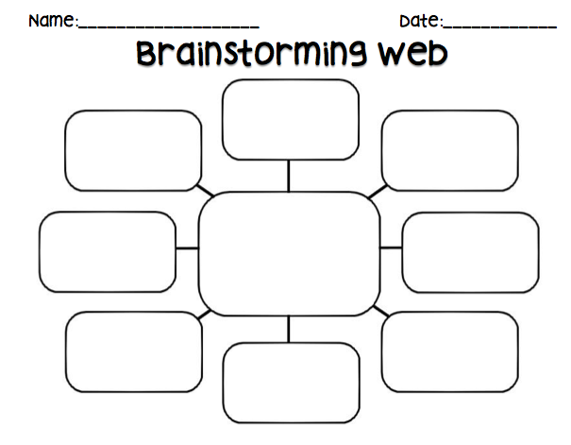

https://www.teacherspayteachers.com/FreeDownload/Brainstorming-Web-1633442

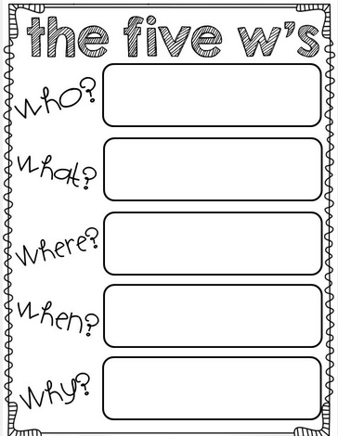

https://www.teacherspayteachers.com/Product/Common-Core-Aligned-Writing-Prompts-for-ANY-Occasion-1114529

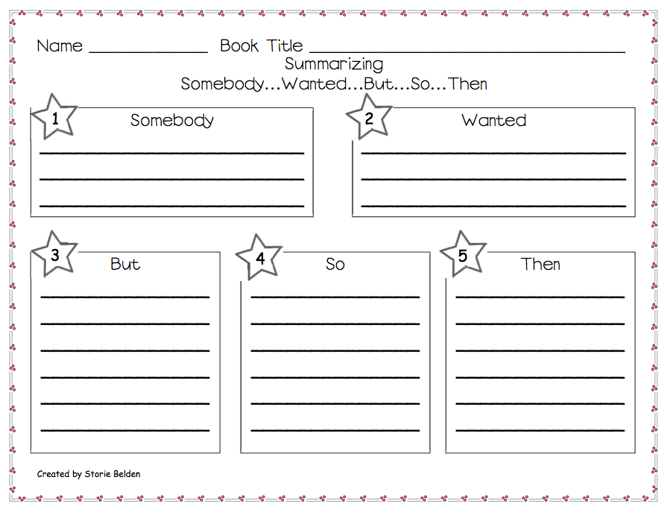

https://www.teacherspayteachers.com/Product/Somebody-Wanted-But-So-Then-Summarizing-Worksheet-244694

You Do:
Remind students that they created a list of things that they like and love in their writing folder and that could be a good place to start.
“Today we are going to explore writing a story that is made up. Do you have an idea that you would like to write about? What do you think your audience would like to hear about? What stories do you have to tell?”
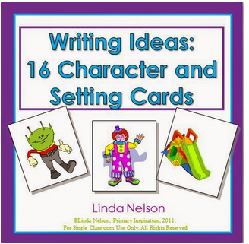
Have students choose a prewriting graphic organizer or make a list. Have students work through the organizers. For those students who are struggling, remind them that they can use pictures to start their writing.
Some students may need story starters. They may use pictures cards to help lay out their stories and to brainstorm ideas.

http://primaryinspiration.blogspot.ca/2012/10/motivate-reluctant-writers-with-this.html

We Share:

When students are finishing up we can gather together as a group. Students can have an opportunity to share their prewriting ideas. They may offer suggestions to their peers about story ideas and help students who may be “stuck”.

Differentiation/Adaptations:

This is embedded into the design of the lesson plan. Students who use an iPad for writing or as a documented adaptation will easily be able to complete this assignment on any app of their choice.
Picture cards could also help students who need support develop ideas

Assessments:

Record observations on students’ prewriting skills in Evernote or however you choose to track your students.

Categories | Level 1 | Level 1 | Level 3 | Level 4
Ideas | Uses 1 simple idea not connected to your topic | Uses 2-3 ideas that are connected to your topic | Uses 4 ideas connected to your topic | Uses 4 or more ideas connected to your topic
Details | Uses 1 supporting detail | Few supporting details but not enough to make the reader see, feel, hear your description | Uses an increasing number of details. | Uses a variety of details to help the reader see, feel, or hear the description
Voice | There is no feeling in your writing | Little feeling about your topic is expressed | Feeling about your topic is expressed | Strong feelings and emotions about your topic is expressed
Sentences | No evidence of simple sentences | Few simple sentences, sometimes incomplete | Simple, complete sentences | Variety in simple and complete sentences
Spelling | Uses only random letters | Uses some spelling strategies | Uses strategies for spelling | Familiar words are spelled correctly
Capital Letters | No capital letters or in the wrong place | Some use of capital letters | Mostly uses capital letters properly | Uses all capital letters accurately
Periods | No periods are used | Some periods at the end of some sentences | Mostly uses periods properly | Uses periods properly
Visual Presentation | Visual presentation is unclear (spacing, placement, legibility | Visual presentation is basically clear | Clear visual presentation | Clear presentation that enhances the writing.
Fiction Writing Rubric

