Unit 1 – Lesson: 7
Writer’s Workshop- Conventions

In this lesson students will begin learning about traits of writing. They will look at conventions in writing and develop an understanding of why it is an important trait.

Topic: Writing Conventions

Time Frame: 45-60 minutes

Driving question: What are some of the rules of writing that we follow?

Curriculum Outcomes –
9: Students will use a range of strategies to develop effective writing and media products to enhance their clarity, precision and effectiveness.

Learning Target:
Grade 1 | Grade 2
Write from left to right, write from top to bottom, use spacing between words, and begin to use capitals at the beginning of sentences. | Use lower case letters within words, use capitals for proper nouns, and use periods correctly.

Resources Needed:
- Screencast: https://www.youtube.com/watch?v=4fHXGhWd6o8

- Computer/LCD project using program of your choice to record student’s answers
- Access to computers or iPads with familiar apps
- Smartboard file: https://drive.google.com/a/gnspes.ca/folderview?id=0B_c7VW5IHTVSfmxtOTZVNlFyTFExckE3WEZ0M25UVjduYmxJQXEwclZFUS1jS1U1V3dWYkE&usp=sharing
- Long sentence strip paper
- Writing Folder – to store writing at various stages
- Writer’s Notebook-­‐ to record ideas and goals for their writing

Lesson:

I Do:
Invite students to turn and talk to a partner about some of the rules they follow when writing. What things do they know about how we write, where we start, how we end a sentence?
Invite students to share their responses. Record student answers on chart paper, iPads, computer, or interactive whiteboard.

Show the screencast:
https://www.youtube.com/watch?v=mSWd_BayWJI
When we follow the conventions or rules of writing it makes our writing easier for our audience to read and understand.

We Do:
There is a smartboard file on capital letters with a sort at the end. This file can be found at: https://drive.google.com/a/gnspes.ca/folderview?id=0B_c7VW5IHTVSfmxtOTZVNlFyTFExckE3WEZ0M25UVjduYmxJQXEwclZFUS1jS1U1V3dWYkE&usp=sharing

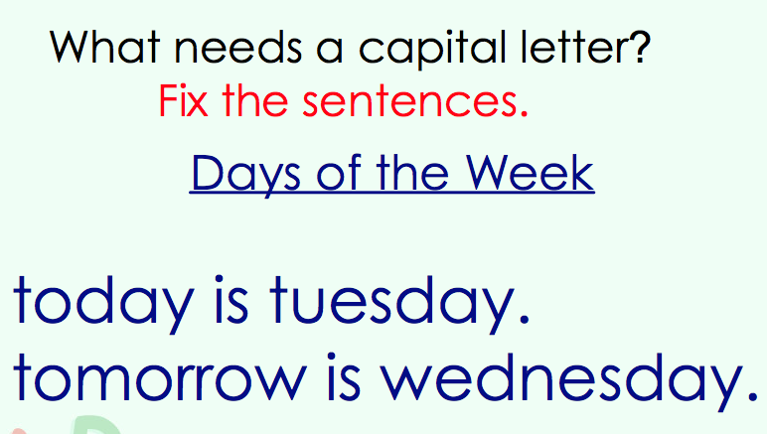
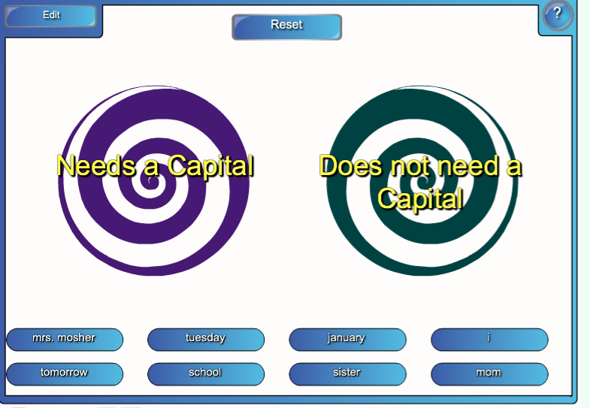
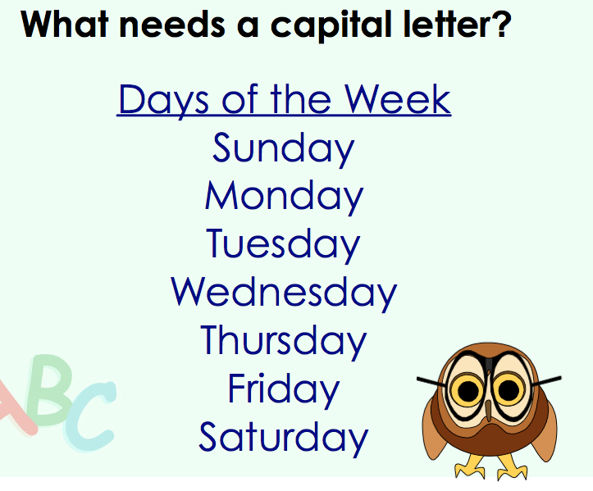

You Do:
Students may use a device or long sentence strip paper for this task. Students can choose a sentence they have already written in their writing folder. They must copy their sentence exactly as they have written it, not making any changes to it. They can exchange their sentence strips or devices with a partner. The partner should highlight changes that need to be made in order to follow the rules of writing.
“This is called peer editing. A peer is someone who is in your class. Editing helps us to follow the rules of writing. “
Students should have 20 minutes to independently write. As students are independently writing, it will be important to conduct one-on-one conferences with students to identify areas of strengths and develop goals for next workshop.

We Share:

When students are finishing up we can gather together as a group. Students can have an opportunity to share their writing samples. If students do not finish, remind students that their writing can be placed in their writing folder and revisited next writer’s workshop or when they finish their other work.
Encourage students to share writing goals that they helped to develop or a part of their writing they feel shows strong use of conventions.

Differentiation/Adaptations:

This is embedded into the design of the lesson plan. Students who use an iPad for writing or as a documented adaptation will easily be able to complete this assignment on any app of their choice.

Assessments:

Collect a writing sample to assess for writing conventions that students have mastered (conventions recording sheet below).
Record observations in Evernote or however you choose to track your students.
https://blog.evernote.com/blog/2011/01/13/10-tips-for-teachers-using-evernote-education-series/

Evernote:

Students Names | Words go from left to right | Writing goes from top to bottom | Use spacing between words | Capitals at the beginning of sentences | Periods
Grade 1 NS Curriculum outcome 9: Students will use a range of strategies to develop effective writing and media products to enhance their clarity, precision and effectiveness.
Conventions Checklist
Students Names | lower cases within words | capital letters | periods | Spacing between words | Awareness of quotation marks
Grade 2 NS Curriculum outcome 9: Students will use a range of strategies to develop effective writing and
media products to enhance their clarity, precision and effectiveness.
Conventions Checklist

